Explore facilitation
Padlet ,
Sand box
Jam board
Divergent - Brainstorming, World Cafe, etc.
Convergent - Affinity Mapping, Criteria Filtering, Voting, etc
Divergent - First phase of group thinking with different ideas – when people are thinking together about a problem
Convergent – when people are starting to come to a common agreement around common solutions
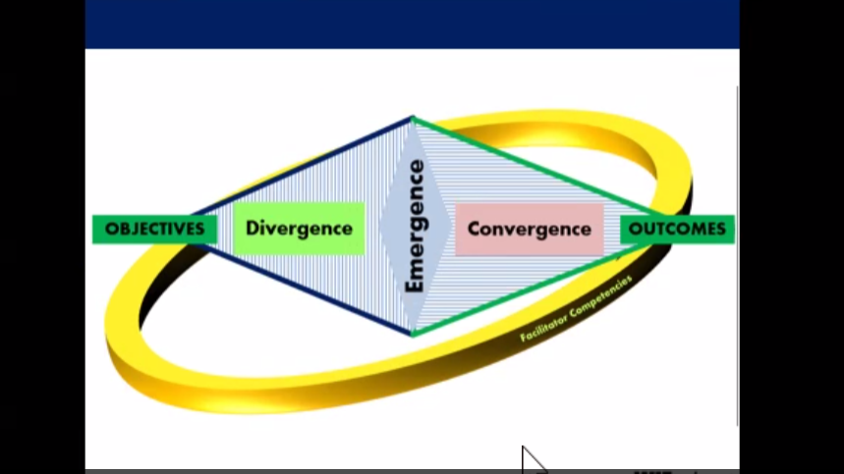
PETS
People
Environment
Time and space

https://padlet.com/wiztalks/card-breakout-room/x2oGAEDQx49mnY3w-page:zsBBT0OajDR5ZXVKb3t4N
Room 2: https://padlet.com/wiztalks/card-breakout-room/x2oGAEDQx49mnY3w-page:l_G6hFRVNdd3tpqSMRT0q
Room 3: https://padlet.com/wiztalks/card-breakout-room/x2oGAEDQx49mnY3w-page:C2iNwP12SYYGFdF20MUkc
Room 4: https://padlet.com/wiztalks/card-breakout-room/x2oGAEDQx49mnY3w-page:dh4m9xCmMGA0uW7mQxRTb
Room 5: https://padlet.com/wiztalks/card-breakout-room/x2oGAEDQx49mnY3w-page:UubG8ceDY54Q3KraAkUi3
Room 6: https://padlet.com/wiztalks/card-breakout-room/x2oGAEDQx49mnY3w-page:5uB68IrScn_389Vnb5d4V

